Graham Fraser Memorial Fellowship Report 2019 – Fearghal Toner
A common theme in keeping with previous fellow’s reports - I can still remember the intense nerves/anxiety as I was taking my seat in front of the rather large interview panel in the Royal College back in September 2017!!
Any minor PTSD from the interview process however was soon forgotten when I received the phone call from Dr. Patricia Fraser the following morning (as I was wandering through the homeware department of John Lewis!) to give me the tremendous news that I had been successful and would be the 2019 Graham Fraser Fellow.

It just so happened that in April 2018 we had a trip planned to see my sister compete in the Commonwealth Games in Brisbane. This allowed my wife Caitriona and I to fly down to Sydney for a day to meet up with Cathy and Andy and we were able to meet up for dinner that evening with Anna. This was a great chance to meet Cathy and chat to Andy and Anna about the fellowship and how to maximise on our time in Sydney.

Andy was a great help in guiding me through all of the paperwork that is required for Visas/AHPRA etc. The process is a bit more straightforward nowadays as a great deal of it is able to be processed online. There are still certain things that need sent physically which can cause some stress while you wait for them to make their way across the world! Thanks to some additional funding sources I was given the opportunity to extend my fellowship period to 9 months – we decided that my wife Caitriona and our daughter would come for the middle 6 of the 9 months. This would give me 6weeks at the start to get up and running, get a car and find somewhere to live etc. without a 1yr year old in tow!
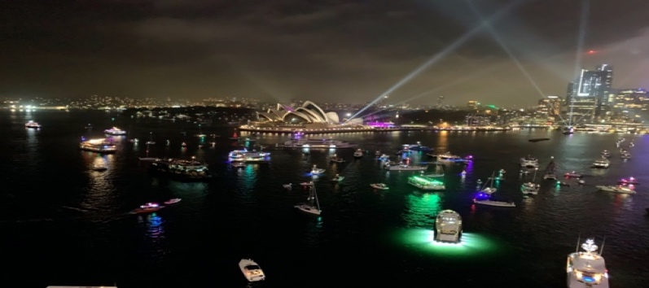
Australia Day celebrations from Harbour Bridge on Jan 31st 2019

Arrival

I arrived in Sydney, via Singapore, late on Sunday the 6th of January and Cathy was kindly waiting for me in the arrival lounge to bring me to my Airbnb in North Sydney. This would be my base for next 3 weeks while I found a rental home/car etc. During the drive Cathy explained that the following day was the Day 5 of the test series between Australia and England at the SCG and enquired (jet-lag dependent!!) if I would like to go with David. Now for me coming from Northern Ireland I have to admit this was my first ever attendance at a cricket match in person and unfortunately the whole day was rained off…!! It was still a lovely way to spend my first day in Sydney however and a great way to meet and get to know David who I worked out fairly quickly was as into any and all sports as much as I was! It would take a couple of weeks to get my accreditation sorted at all of the hospitals – this gave me some time to adjust to the temperature change (40ºC!!) …. I even managed to squeeze in a weekend trip to Melbourne for the Australian Open!
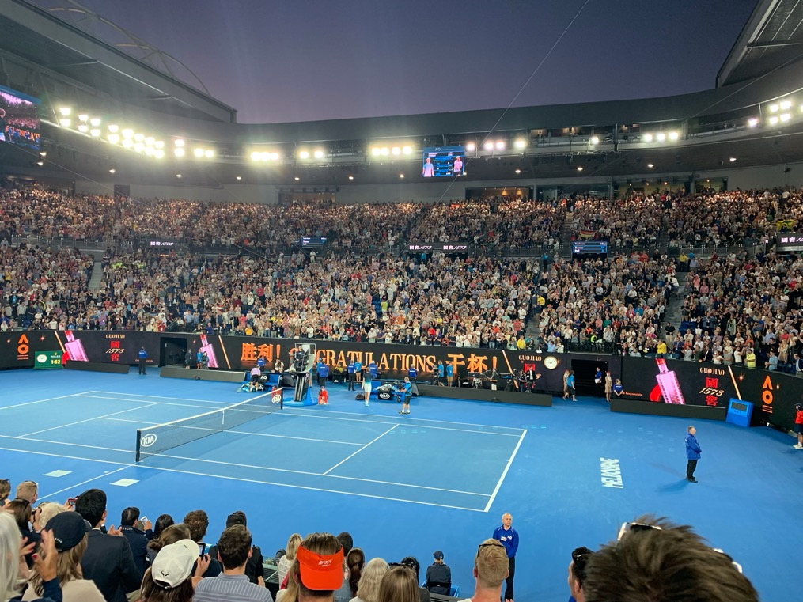

Clinical experience

Once I had completed the in-person paperwork that is required and my tour of the 4 hospitals (Public – RPA/Children’s Westmead and Private – SAN/MUH) to get ID’s and IT passwords etc. I began the clinical fellowship close to the end of January. The timetable was as below:

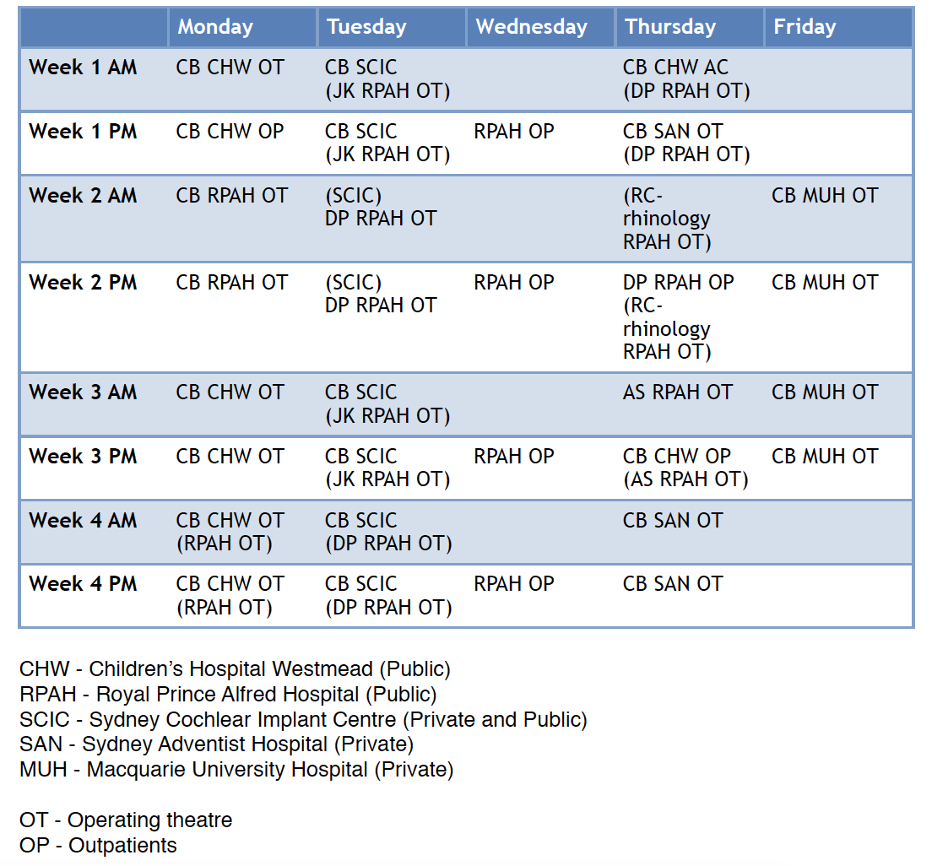

I was involved in 84 Cochlear implants during my 9 months in Sydney, this included 16 bilateral implants on children and 1 bilateral simultaneous on an adult (a first for Cathy and me!) After the first couple of “getting to know you” weeks and learning the process by which Cathy performs her CI surgery I was able to perform the bulk of the public CI’s solo. During the private CI cases I would perform the bony approach work before Cathy would complete the insertion. As a consequence of Cathy’s, and rest of team at SCIC, expertise in managing children with complex needs I had the opportunity to be involved in a large number of cases in children with conditions such as CHARGE. The time and effort that Cathy and the team would spend with the families of these children was tremendous and a real learning opportunity for me which will greatly enhance my future practice.

Some of the many surgical highlights during my time include being involved in the implantation of 3-month old (4kg!) infant who required CI after a hearing loss due to meningitis. This was by far the youngest child I personally had seen implanted and so was technically great to see. The new 6 series Cochlear devices were released towards the end of my time in Sydney and due to a quirk in the order of the operating lists I was able to claim (for a whole 72hours) to be the most-experienced CI 6-series surgeon in Australia!!!

Tuesdays were spent at SCIC for the Cochlear implant clinic, here I would see both new and follow-up CI patients. This was a great opportunity and allowed me to appreciate the whole patient journey – form initial referral, workup, surgery and post-op switch on and outcomes, which as an ENT trainee working in the NHS is often not possible. The weekly MDT during which SCIC centres from around NSW and Australia join via video-link was also a tremendous learning opportunity to reflect and discuss common issues experienced by the CI population and how the team would manage these.

Professor Bill Gibson is still very actively involved in clinical work at SCIC and I had the privilege of sitting in on some of his clinics, discussing cases with him, and learning more about his electrophysiological testing methods particularly in patients with Meniere’s.

As well as operating experience I found my time spent at the Children’s Hospital in Westmead invaluable – the Paediatric Hearing loss and monthly Microtia/Atresia clinics provided a unique opportunity for gaining experience in the investigation and management of varied and often times unusual/rare causes of hearing issues. BAHA (Connect/Attract) and Bonebridge devices were also a feature on the paediatric lists here.

During my 9 months I was also able to develop my general otology experience being involved in cases of cholesteatoma, ossiculoplasty and lateral skull base surgery. In RPA I was given the opportunity to attend operating lists and clinics with Dr. Kong and Dr. Saxby who are part of Sydney Endoscopic Ear Group and have vast experience in the endoscopic otology field. My extension of the fellowship to 9 months also allowed me to attend the Sydney Endoscopic Ear Course in September, this is a fantastic course with a world class faculty that I highly recommend.

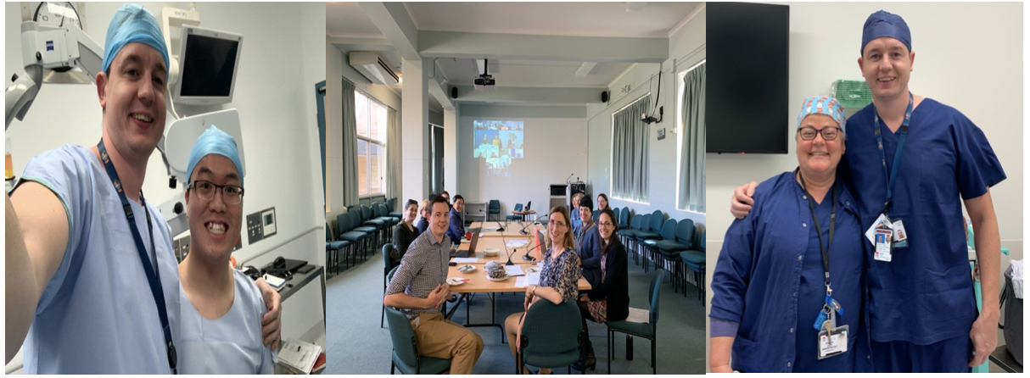
Me along with the new Halit – Philip! SCIC team at the MDT Dr. Elspeth Bright (Super Anaesthetist!)

The local trainees in RPA and Westmead and Otology Fellow Casey Vaughn in RPA were great colleagues and put up stoically with my lack of knowledge of how the healthcare system in Australia worked and constant questions!

Research and Education

Research is an important aspect of the fellowship and near the outset I discussed with Cathy what my research goals were. I initially completed some final data collection and analysis of a project that my immediate predecessor, Andy, had started into impedances after array reinsertion. This is currently under consideration and should be (hopefully!) published in the near future.
My main research project was into the area of hearing loss and cognition specifically in the CI setting. Using the Montreal Cognitive assessment tool modified for use in the hearing impaired, we ran a pilot study investigating the prevalence of cognitive impairment in those patients over 65 who had received a CI. This provides both an interesting snapshot of our CI population but will also now be used going forward in SCIC to assess patients pre and post implantation to see what effects receiving a CI may have on cognitive performance.
I was involved in the provision of a seminar on ANSD and gave a lecture on the Pre-Implant Counselling and Post-Implant Outcomes for Patients with ANSD. I was also asked to be part of the supervising faculty for a temporal bone course ran by the team at RPA for local trainees.

Sydney / Travel

We ended up in renting in Neutral Bay during our time in Sydney – this was a fabulous location – nicely located near the city (10mins on the bus) but also near to great northern beaches locations such as Balmoral beach, Manly and Taronga zoo – which was nearly a weekly visit for Caitriona and Ava to see the giraffes and meercats! Staying in Neutral Bay also meant that our local swimming pool became the Sydney Olympic pool, which was no less stunning with each visit! Due to Cathy’s hectic schedule of conferences and invites to talk around the globe we had multiple opportunities to travel and see the major Australian landmarks. Some of the highlights included Uluru, the Great Ocean road, Hamilton Island and we even managed a trip to Bali before Caitriona and Ava flew back to Belfast in August!

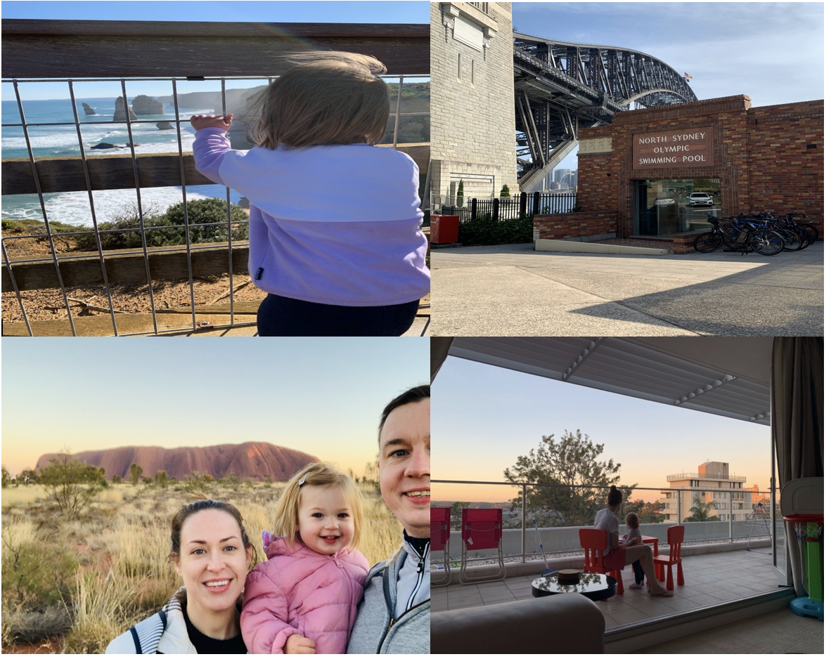
Clockwise from Top left – Ava and 12 Apostles – “Local” pool – Dinner alfresco on balcony – Family sunrise selfie at Uluru

As a sporstfan Sydney was a great city to be in - among some of the events I was able to experience, in addition to the tennis, included a couple of AFL matches, a 20/20 cricket match at the SCG courtesy of David again, a few NBL basketball games and - thanks to Richard Fox on of the Reg’s in RPA - I also had the fortune to be at the deciding match of the 2019 State of Origin series – which thankfully the Blues won on a last second try!!

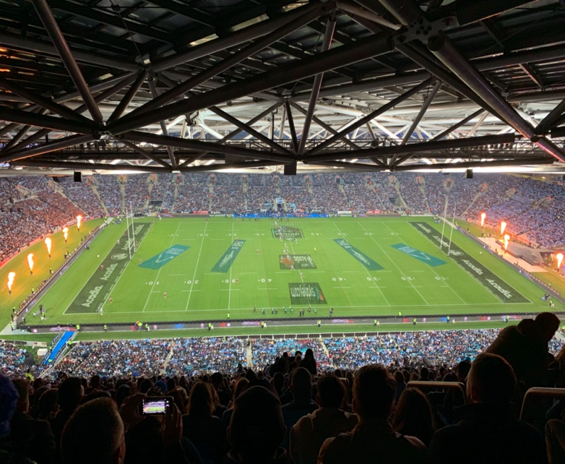

Other Opportunities

Alongside my clinical work I had the opportunity to attend a number of courses and conferences during my 9 month fellowship. I was able to take part in a practical course ran by Cochlear at their Sydney HQ for implant surgeons from Asia/Pacific, this included a tour of their HQ and the University of Sydney’s anechoic chamber. Fortunately towards the end of my time the Australia New Zealand Society of Paediatric otorhinolaryngology conference was being held in Sydney, this was an excellent opportunity to hear and learn from experienced ENT surgeons specialising in Paediatrics ORL in tertiary and quaternary centres around NZ and Australia.

Cathy/David and the Birman/Whittle Family

From day 1 in Sydney, Cathy/David and the whole family were tremendously welcoming and supportive. We were hosted for numerous lunches and BBQ’s – including the Whittle/Birman Easter Sunday and David’s birthday celebrations! Getting to know the extended family was a great privilege; including the 2 smaller; but just as important family members – Mia and Zoe – who were both big hits with our daughter Ava! The various get togethers also allowed for regular discussions and updates on the progress (or not) of Brexit - which we could not escape even from 10,000 miles away!!!

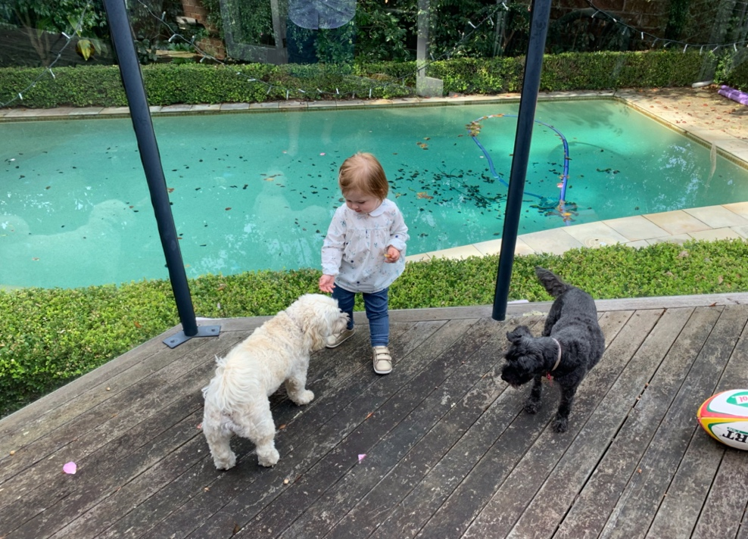

I would like to thank Dr Patricia Fraser, the Graham Fraser trustees and Med El for continuing to organise and support this incredible fellowship opportunity. Our 9 months in Sydney is something we will always remember and was such a tremendous time, from both a professional development and family experience point of view.
Cathy is an incredible mentor and teacher and the skills and knowledge acquired from my time working with her and the rest of the team in Sydney will aid me from day 1 in my future career as a consultant.
I cannot recommend the fellowship highly enough to those with an interest in CI/Otology and am proud to have my name on the list of past Fellows.

