Graham Fraser Memorial Fellowship Report – 2020 Nishchay Mehta

Preceding preamble
Between the internationally renowned otologists on the interview panel and the list of distinguished Graham Fraser alumni, I found the idea of an application for the GF fellowship daunting to the point of inaction. Thankfully I was admonished and encouraged by my good friend, and previous recipient Andy Hall, to buckle down and get on with it! I followed orders and somehow found myself in a surreal moment receiving a phone call from Dr Pat Fraser congratulating me. Whilst I cannot remember my exact response, based on the looks of those around me, I suspect it was not in keeping with the decorum of the ward round I happened to be attending.

Since I’d perceived minimal chance of success, I hadn’t really contemplated the difficulties of moving my young family half way across the globe for 6 months. I had an upcoming consultant interview for my dream job, my wife was employed as a Locum Consultant Neurologist and my children (then 7&5 years old) were in an excellent school. The logistics of uprooting oneself and ones’ family from anchors that had taken time and effort to establish,with the hope of re-mooring shortly thereafter,were nearly insurmountable. But thankfully we had very supportive colleagues and an understanding headteacher which helped the barriers melt away one by one.

Over the course of the ensuing year I slowly chipped away at the mammoth task of AHPRA registration and temporary training visa applications, whilst my wife began organizing kids’ schooling and our Sydney accommodation. To save on repetition I will focus on schools and accommodation, which I have placed at the end of the report.

Arrival
We arrived on January 4th 2020, hottest day of the NSW summer, to a 38C welcome.Prof Birman was in Germany, but despite that she had very generously organized for a car to pick us up from the airport. Her generosity would become a recurring theme. We used our time at the airport to buy mobile phone SIM cards. The first two weeks were used to formaliseprovisional AHPRA approvals, get contracts signed at the host institution (Royal Prince Alfred Hospital), get Working With Children Checks formalized at an NSW service station, accreditations organized at all sites (RPAH/Macquarie University /Sydney Adventist/Children’s hospital Westmead) and start the process of getting provider numbers at private hospitals (MUH & SAN).

Clinical
My timetable was as below:

 | Mon | Tue | Wed | Thurs | Fri
am | Week 1 CHW Surg  Week 2 RPA Surg  Week 3 CHW Surg  Week 4 CHW Surg | Week 1-4  SCIC Clin | Week 1-4  Research | Week 1 SAN Surg  Week 2 Free  Week 3 CHW microtia clin  Week 4 SAN Surg | Week 1 Free  Week 2 MUH Surg  Week 3 MUH Surg  Week 4
pm | Week 1 CHW Clin  Week 2 RPA Surg  Week 3 CHW Surg  Week 4 CHW Surg | Week 1-4  SCIC Clin | Week 1-4  RPA Clin | Week 1 SAN Surg  Week 2 Free  Week 3 CHW Clin  Week 4 SAN Surg | Week 1 Free  Week 2 MUH Surg  Week 3 MUH Surg  Week 4

Clinics
In clinics you are generally supernumerary and have a great opportunity to learn from Prof Birman. Her referral base includes very young children with complicated hearing test results, or with additional congenital and anatomical abnormalities. This really allowed me to understand the nuanced benefits of electrophysiological tests in children with little evidence of auditory nerves on scanning.

Tuesdays were also spent attending SCIC regional MDT. Difficult clinical and audiological cases were discussed and it the broad membership of the team, especially the engineers, were vital in devising management plans for these patients.

Prof Birman encouraged me to sit in with others and I enjoyed many Meniere’s clinics with Prof Bill Gibson and a balance clinic with Prof Welgampole. My RPA counterpart Rhydian Harris provided me with a timetable of concomitant operating at RPAH and Prof Birman was happy for me to miss my routine timetable slots to attend any of these extra theatre sessions for cases that were interesting.

Wednesdays were spent at RPAH where I organized teaching for final year registrars about to take their exam and then a general clinic.

Once a month on Thursdays I did a multi-disciplinary microtia/atresia clinic with a paediatrician, social worker, plastic surgeon and audiologists. It was a fantastic clinic that holistically managed these children with multiple needs. I developed a deeper understanding of non-surgical audiological rehabilitation options and of the implications of surgical rehabilitation on future pinna reconstruction.

Surgery
Covid-19 reports emerged in mid-December 2019 and by late March all elective workload had ceased in Australia. Other than emergency or Covid-19 related work April was spent by most Australian clinicians in strict lockdown. Towards the end of April very few Covid-19 cases had been identified in Australia and the government made plans to slowly restart elective clinical work. Whilst elective work restarted in May it was at a considerably slower pace than the pre-Covid era. Despite this backdrop I participated in 34 cochlear implants, most of which were done in children under the age of 1 and with congenital abnormalities.

Prof Birman quickly demonstrated her technique to me with excellent commentary on rationale. In the private hospitals I would undertake the approach and Prof Birman the insertions whilst in the public sector I was much more involved and had the opportunity to hone my skills. The public sector had the children with the most difficult anatomy and so my learning curve was steep. It was not uncommon to encounter multiple facial nerve branches,anotia or rotated cochleae. I was also able to undertake several CN632 insertions by cochleostomy which was an electrode I had previously little experience with.

Additionally, I undertookfive bone anchored hearing aid insertions and participated in the implantation of a prototype device. I undertook two large disease volume combined approach tympanomastoidectomies and participated in three more. I also got to undertake multiple endoscopically assisted butterfly graft myringoplasties.

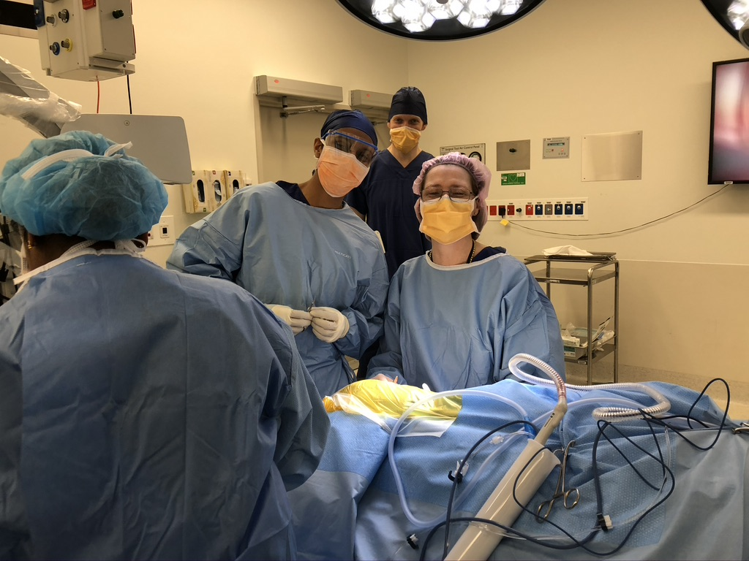

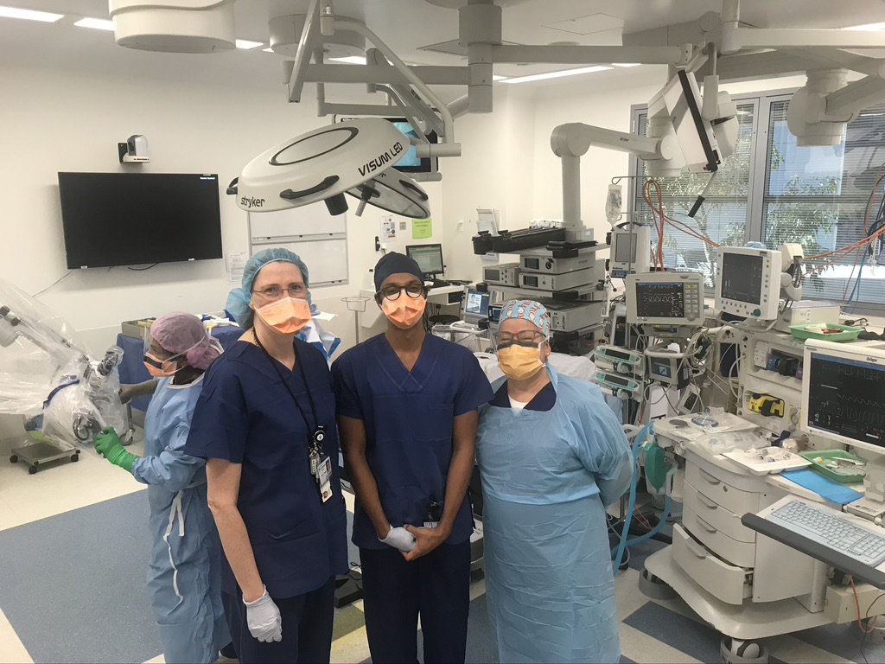

Research
Since Covid-19 had imposed restrictions on surgery,Prof Birman and I focused our attention on research. We had discussed the utility of intraoperative electrophysiology, as it considerably time consuming and not routinely done in units I’d worked in. I was given a dataset of 235 consecutive patients who had undergone intraoperative testing and for whom we had post-operative impedance results. I analysed the ability of intraoperative testing to predict longer term impedance abnormalities in the implants. The results were surprising to both and the paper has now been submitted for publication.

Prof Birman had noted that recent post-operative speech outcomes had been better than previous and she wondered whether the improved accessibility of direct auditory inputs for the new cochlear implants improved rehabilitation. To undertake this project, we needed post-operative speech outcomes compared to user data stored locally on proprietary implant manufacturer software. Working with Philip Chu (the excellent in-house engineer), we were able to generate a Python-based pipeline that merged and curated the clinical dataset with implant user data. We are currently analyzing the dataset to study the impact of direct auditory inputs on speech outcomes, but the design of this data pipeline allows future researchers in Prof Birman’s team to answer many more pertinent clinical questions.

I was involved in recruiting patients into two active clinical trials and sat in research meetings with the broader research group. This fellowship offers considerable opportunity for research given the vast amount of data that has been collected and the interesting group of patients that SCIC has amassed.

Accommodation
We looked at the geographical distribution of the hospitals I’d be working at and the modes of transport available. We had decided that buying or hiring two cars would be too costly. Areas in Sydney we liked either had poor transport links or missed out on the quintessential beach experience. Therefore, we considered living close to Central station, which would allow me to use the excellent transport links to get to nearly all of fellowship’s clinical sites and close enough to the beaches for the family to experience afterschool beach activities.

Accommodation in Sydney is mostly unfurnished and is only advertised 2 months from availability. In addition, there were very few short term, 6-month, lease available. We were made aware of the website sabbaticalhomes.com by some academic friends, where accommodation/ house swaps were posted by professionals undertaking periods of international travel. We were lucky enough to find a fully furnished town house in Surry Hills, within the catchment of an excellent school, walking distance to Central station, buzzing café and restaurant scene, and within 15 mins drive to most of the Eastern suburbs’ beaches. We also rented their car and the home came complete with a good selection of children’s toys and books.

Schooling
Under the Temporary Residents Programme, children of temporary resident visa holders can attend state funded schools. For visa 407, there is a fee to pay. The NSW government school system is such that if you live within the catchment area of a school, they have an obligation to take your child(ren), and this is an important factor to consider if you are undertaking the fellowship with school-aged children. The school year they enter is dependent on their birth date. Once we had found our accommodation, we were able to contact the school, who confirmed that they would be able to take our children, as long as we had the necessary paperwork.

This process was tackled by my wife as I dealt with the AHPRA/ visa applications. Before you leave the UK, try to get a summary of your child’s immunization history. There were 3 main processes:
- Application for an Authority to Enrol, which is a more central process. One part of the form needs to be signed bythe school you intend to go to. Schools are however shut most of December and January for the summer holiday, and so will not be able to fill the form until they open at the end of January. We sped the process up by sending the form, with that part unfilled, to the Dept of Education NSW first so the application would be registered and given a reference number. Once school opened, we completed the missing part, paid, and our application was approved.
- Parallel to this, in order to attend school, your child’s immunizations must be up to date and registered on Medicare. Once registered on `Medicare (reciprocal agreement between Australia & the UK), we made an appointment with a GP, who then had the immunizations records uploaded onto our Medicare account. Once this is processed you can then print out a certificate for the school.
- Once the Authority to Enrol has been approved, you have to demonstrate that you live within the school’s catchment area and complete the local process. You need to confirm your address via the ‘100 ID point’ system.

Our children really enjoyed going to school in Sydney.

Extra-curricular activities
Sydney seems to have seamlessly blended laid-back beach life with the bustle of hip inner-city life. The two populations enjoying these worlds may initially seem incongruous, united only by their love of flat whites, beers and sports. But as time passed, we noticed that the populations were the same, just swapping their trendy city clothes to their beachwear as the condition demanded! We took a leaf from their books and did the same.

Prior to Covid, the children werefairly busy with school and afterschool activities during the week, and spent the weekends learning how to surf and spending lots of time on the beach. As Cathy was away in Europe when we first arrived, we managed to visit Melbourne for the Australian Open, and did the Great Ocean Road. Covid meant that unfortunately our inter-state travel plans were no longer possible; we however took the opportunity to explore other Sydney suburbs and NSW.We drove out and enjoyed the many trails (aka ‘bush walk’) and beaches in Ku-Ring-Gai national park, Palm beach, Blue Mountains, Narrabean, Kiama, Hunter Valley, Port Stephens and many more beautiful places of outstanding beauty… definitely not a bad place to be socially isolating at!

Overall, this fellowship offers an excellent opportunity to hone skills for any trainee who wants to dedicate their career to auditory implants and have an amazing life experience.

I would like to thank the Graham Fraser Trustees and Med-EL for offering me this fantastic opportunity, and my colleagues at the Royal National ENT hospital for encouraging me to undertake this prestigious fellowship.

I would also like to thank Prof Birman who was a wonderful host, learned tutor, instructive surgical supervisor, brilliant researcher and mostly an amazing friend. Part of my fellowship was marred by the Covid-19 pandemic and it would have been an extremely difficult time if it were not for her amazing support. She was always on hand, easy to contact and extremely generous.

I wholeheartedly and without reservation recommend this fellowship to any trainee who wants a career as an otologist at a teaching hospital.

